No. | Answer
n(SO₂) = 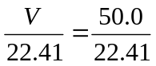 = 2.231 mol
n(H₂SO₄) = n(SO₂)
m(H₂SO₄) = n × M = 2.231 × 98.076 = 219 g
n(NaHCO₃) = c × V = 2.86 × 0.0299 = 0.08551 mol = n(HCO₃–)
n(H⁺) required = n(HCO₃–) = 0.08551 mol = n(HCl)
c(HCl) = 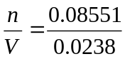 = 3.59 mol L^{–1}
a 2NaN₃(s) → 2Na(s) + 3N₂(g)
b n(NaN₃) = 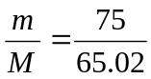 = 1.15 mol
n(N₂) = 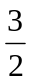 × n(NaN₃) = × 1.15 = 1.73 mol
V(N₂) = n(N₂) × 22.41 = 39 L
m(Br₂) = density × volume = 3.12 × 10.0 = 31.2 g
n(Br₂) = 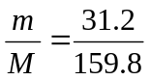 = 0.1952 mol
n(NaOH) = 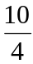 × n(Br₂) = 0.4881 mol
c(NaOH) = 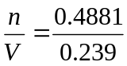 = 2.04 mol L^{–1}
a n(As) = 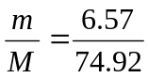 = 0.08769 mol
n(NaOH) = c × V = 0.779 × 0.250 = 0.1948 mol = n(OH–)
mole ratio, in reaction of As : OH– = 1 : 3,
∴ 0.08769 mol of As would react with 0.2631 mol of OH–
∴ OH– is the limiting reagent.
n(H₂) produced = × n(OH–) = × 0.1948 = 0.0974 mol
m(H₂) = n × M = 0.0974 × 2.008 = 0.196 g
b n(AsO₃^{2–} formed in reaction) = × n(OH–) = × 0.1948 = 0.06493 mol = n(Na₃AsO₃)
c(Na₃AsO₃) = 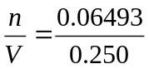 = 0.260 mol L^{–1}

